**DBMS PROJECT PHASE-1**

|  |  |
| --- | --- |
| **NAME** | **ID NUMBER** |
| Vedansh Srivastava | 2019A7PS0323H |
| Navam Shrivastav | 2019A7PS0092H |
| Tejas Tripathi | 2019A7PS0059H |
| Aryan Saraf | 2019A7PS0138H |

**E.R. DIAGRAM**

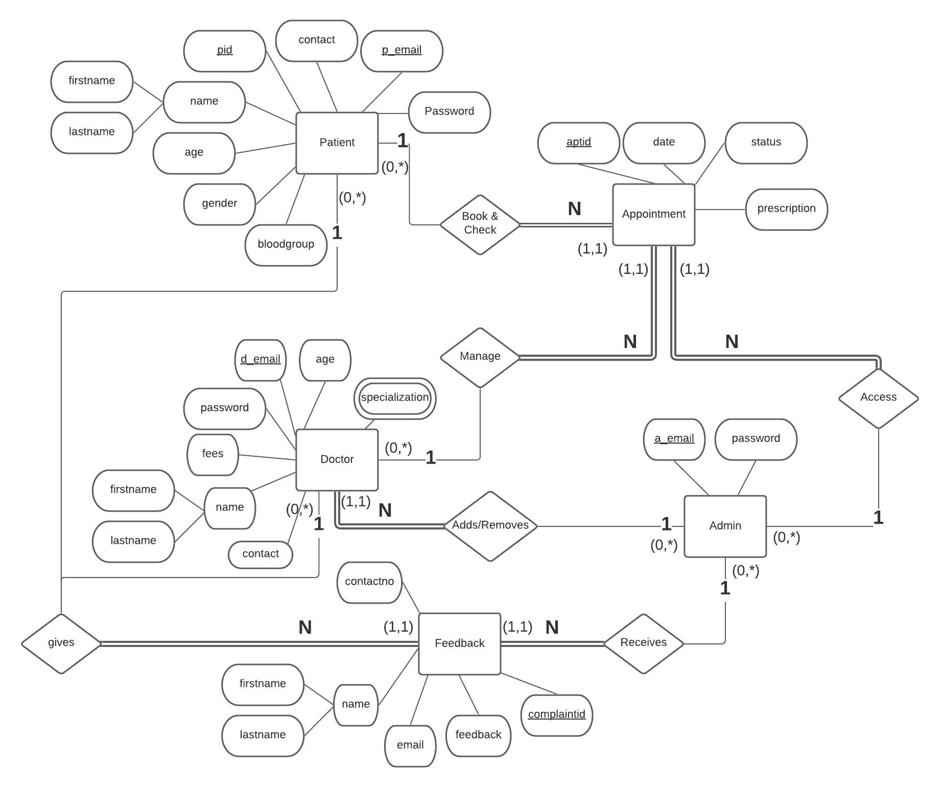

**RELATIONAL SCHEMA**

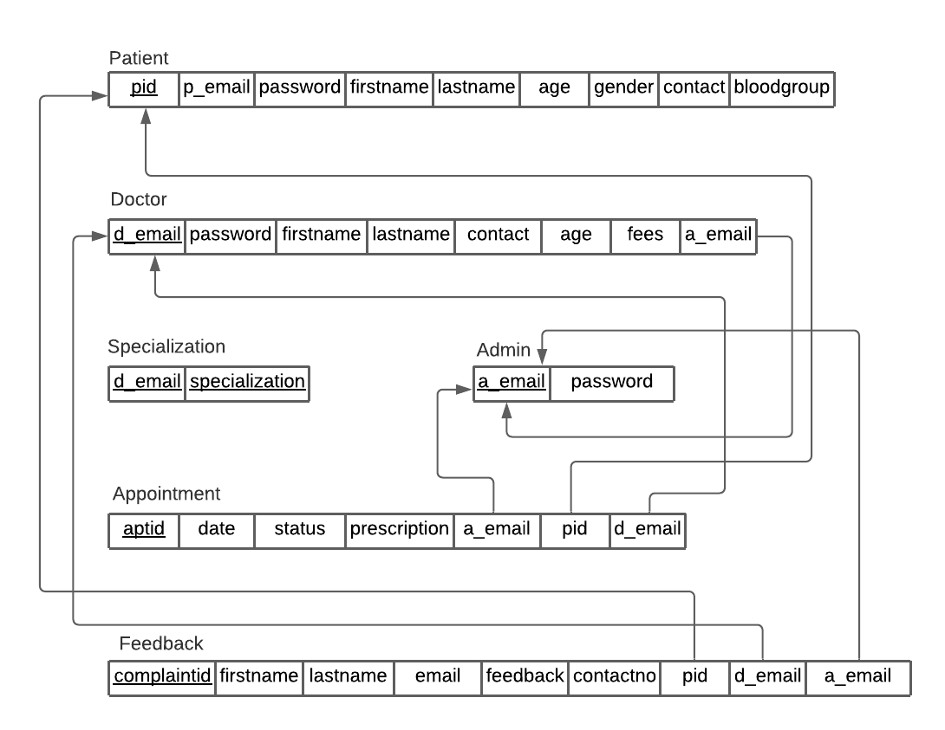

**INSERTING DUMMY VALUES**

PATIENT

|  |  |  |  |  |  |  |  |  |
| --- | --- | --- | --- | --- | --- | --- | --- | --- |
| **pid** | **p_email** | **password** | **firstname** | **lastname** | **age** | **gender** | **contact** | **bloodgroup** |
| 1201 | p1@gmail.com | p1pass | Aryan | Saraf | 19 | Male | 9876543210 | B+ |
| 1202 | p2@gmail.com | p2pass | Tejas | Tripathi | 20 | Male | 9987654320 | O- |

DOCTOR

|  |  |  |  |  |  |  |  |
| --- | --- | --- | --- | --- | --- | --- | --- |
| **d_email** | **password** | **firstname** | **lastname** | **contact** | **age** | **fees** | **a_email(FK)** |
| d1@gmail.com | d1pass | Navam | Shrivastav | 9638527412 | 33 | 650 | admin@gmail.com |
| d2@gmail.com | d2pass | Anandi | Bajpai | 9638527410 | 35 | 450 | admin@gmail.com |

SPECIALIZATION

|  |  |
| --- | --- |
| **d_email** | **specialization** |
| d1@gmail.com | cardiology |
| d1@gmail.com | oncology |
| d1@gmail.com | physician |
| d2@gmail.com | neurology |
| d2@gmail.com | physician |

ADMIN

|  |  |
| --- | --- |
| **a_email** | **password** |
| admin@gmail.com | admin123 |

APPOINTMENT

|  |  |  |  |  |  |  |
| --- | --- | --- | --- | --- | --- | --- |
| **aptid** | **date** | **status** | **prescription** | **a_email (FK)** | **pid(FK)** | **d_email(FK)** |
| 4201 | 16-MAR-2021 | Pending | NULL | admin@gmail.com | 1202 | d2@gmail.com |
| 4202 | 19-MAR-2021 | Cancelled- Doctor | NULL | admin@gmail.com | 1201 | d1@gmail.com |

FEEDBACK

|  |  |  |  |  |  |  |  |  |
| --- | --- | --- | --- | --- | --- | --- | --- | --- |
| **complaintid** | **firstname** | **lastname** | **email** | **feedback** | **contactno** | **pid(FK)** | **d_email(FK)** | **a_email(FK)** |
| 101001 | Vedansh | Srivastava | vs@gmail.com | Services are good. | 8081452256 | NULL | NULL | admin@gmail.com |
| 101002 | Manas | Gupta | mg@gmail.com | Staff should focus on cleanliness. | 8738953336 | NULL | NULL | admin@gmail.com |
| 101003 | Tejas | Tripathi | p2@gmail.com | Doctor was very arrogant. | 9987654320 | 1202 | NULL | admin@gmail.com |
| 101004 | Anandi | Bajpai | d2@gmail.com | Cabin A/C not working. | 9638527410 | NULL | d2@gmail.com | admin@gmail.com |

**SQL QUERIES TO MAKE TABLES AND INSERT DATA**

**CREATING PATIENT TABLE:**

create table patient (

pid int,

p_email varchar(50) UNIQUE NOT NULL,

password varchar(20) NOT NULL,

firstname varchar (20) NOT NULL,

lastname varchar (20),

age int NOT NULL ,

gender varchar(9) NOT NULL,

contact int NOT NULL,

bloodgroup varchar (2),

PRIMARY KEY (pid),

CHECK(p_email LIKE '%@%.com'),

CHECK(gender in ('Male', 'Female', 'Unknown')),

CHECK (age<=119)

);

**INSERTING PATIENT DATA:**

insert into patient values(1201,'p1@gmail.com','p1pass','Aryan','Saraf',19,'Male',9876543210,'B+');

insert into patient values(1202,'p2@gmail.com','p2pass','Tejas','Tripathi',20,'Male',9987654320,'O-');

**CREATING ADMIN TABLE:**

create table admin(

a_email varchar(50) PRIMARY KEY,

password varchar(20) NOT NULL

);

**INSERTING ADMIN DATA:**

insert into admin values ('[admin@gmail.com](mailto:admin@gmail.com)','admin123');

**CREATING DOCTOR TABLE:**

create table doctor (

d_email varchar(50) PRIMARY KEY,

password varchar(20) NOT NULL,

firstname varchar (20) NOT NULL,

lastname varchar (20),

contact int NOT NULL,

age int NOT NULL,

fees int NOT NULL,

a_email varchar(50) NOT NULL,

CHECK(a_email LIKE '%@%.com'),

FOREIGN KEY (a_email) REFERENCES admin(a_email),

CHECK (fees BETWEEN 100 AND 1000)

);

**INSERTING DOCTOR DATA:**

insert into doctor values ('d1@gmail.com', 'd1pass', 'Navam', 'Shrivastav', 9638527412,33,650,'[admin@gmail.com](mailto:admin@gmail.com)');

insert into doctor values('[d2@gmail.com](mailto:d2@gmail.com)','d2pass','Anandi','Bajpai',9638527410,35,450,'admin@gmail.com');

**CREATING SPECIALIZATION:**

create table specialization (

d_email varchar(50),

specialization varchar (20),

PRIMARY KEY (d_email, specialization)

);

**INSERTING SPECIALIZATION FIELDS:**

insert into specialization values('d1@gmail.com','cardiology');

insert into specialization values('d1@gmail.com','oncology');

insert into specialization values('d1@gmail.com','physician');

insert into specialization values('d2@gmail.com','neurology');

insert into specialization values('[d2@gmail.com](mailto:d2@gmail.com)','physician');

**CREATING APPOINTMENT TABLE:**

create table appointment (

aptid int PRIMARY KEY,

dated varchar(10) NOT NULL,

status varchar (20) DEFAULT 'Active',

prescription varchar(50) DEFAULT 'Not yet consulted',

a_email varchar(50) NOT NULL, pid INT NOT NULL, d_email varchar(50) NOT NULL,

FOREIGN KEY(a_email) REFERENCES admin(a_email),

FOREIGN KEY(pid) REFERENCES patient(pid),

FOREIGN KEY(d_email) REFERENCES doctor(d_email),

CHECK (dated like '__-__-____') );

**INSERTING APPOINTMENT TABLE DATA:**

insert into appointment (aptid,dated,status,a_email,pid,d_email) values (4201,'16-03-2021','Pending','admin@gmail.com',1202,'d2@gmail.com');

insert into appointment (aptid,dated,status,a_email,pid,d_email) values (4202,'19-04-2021','Cancelled-Doctor','admin@gmail.com',1201,'d1@gmail.com');

**FEEDBACK TABLE CREATION:**

create table feedback (

complaintid int PRIMARY KEY,

firstname varchar (20) NOT NULL,

lastname varchar (20),

email varchar(50) NOT NULL,

feedback varchar(80) NOT NULL,

contactno int NOT NULL,

pid int, d_email varchar(50), a_email varchar (50) NOT NULL,

FOREIGN KEY (pid) REFERENCES patient(pid),

FOREIGN KEY (d_email) REFERENCES doctor(d_email),

FOREIGN KEY (a_email) REFERENCES admin(a_email)

sad);

**INSERTING FEEDBACK DATA:**

insert into feedback (complaintid,firstname,lastname,email,feedback,contactno,a_email) values

( 101001, 'Vedansh', 'Srivastava', 'vs@gmail.com', 'Services are good.', 8081452256, '[admin@gmail.com](mailto:admin@gmail.com)');

insert into feedback (complaintid,firstname,lastname,email,feedback,contactno,a_email) values

( 101002, 'Manas', 'Gupta', 'mg@gmail.com', 'Staff should focus on cleanliness.',8738953336, '[admin@gmail.com](mailto:admin@gmail.com)');

insert into feedback (complaintid,firstname,lastname,email,feedback,contactno,pid,a_email) values

( 101003, 'Tejas', 'Tripathi', 'p2@gmail.com', 'Doctor was very arrogant.', 9987654320, 1202,'[admin@gmail.com](mailto:admin@gmail.com)');

insert into feedback (complaintid,firstname,lastname,email,feedback,contactno,d_email,a_email) values

( 101004, 'Anandi', 'Bajpai', 'd2@gmail.com', 'Cabin A/C not working.', 9638527410,'[d2@gmail.com](mailto:d2@gmail.com)', '[admin@gmail.com](mailto:admin@gmail.com)'

);

**\*\*\*\*\***